**SALESMAN MODULE**

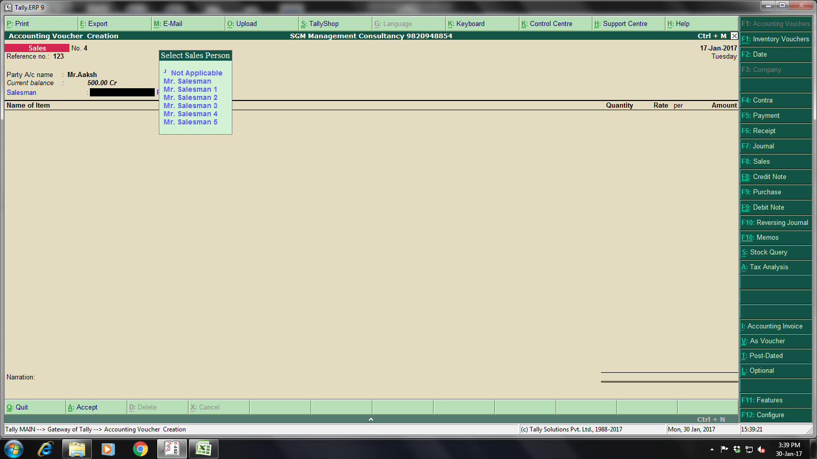

**Select Salesman**